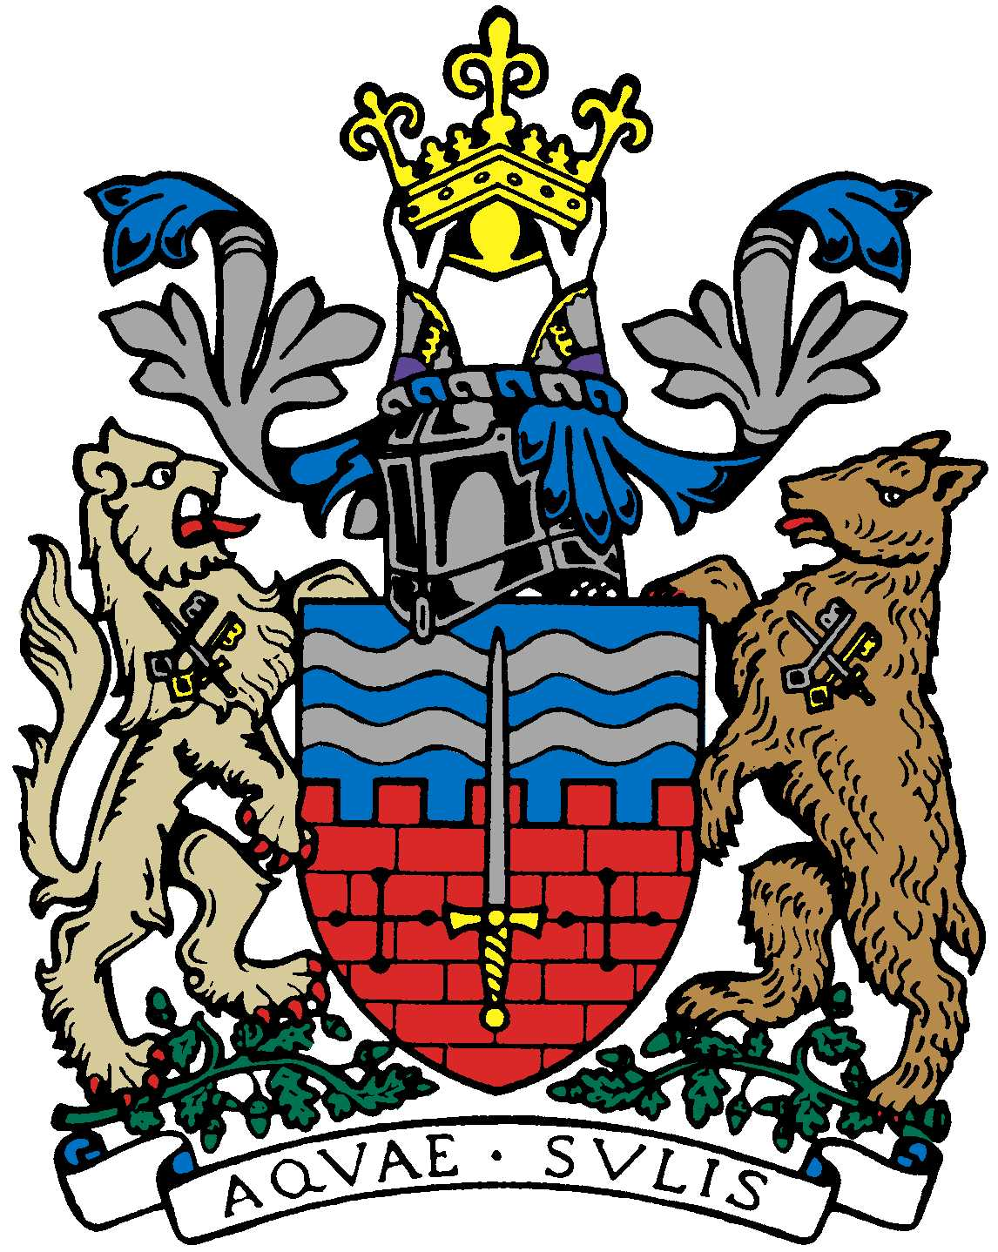 | Bath Beppu Friendship Association  Meeting Notes  23rd March 2021 18:00  Meeting held virtually on Zoom | 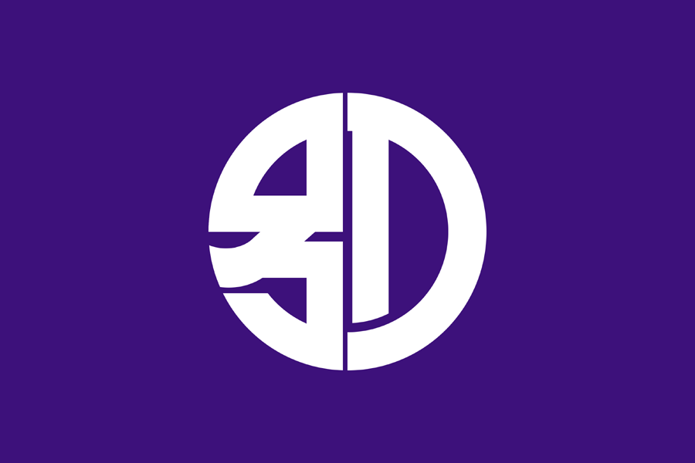

Attendees: | Paul Crossley (PC) Chair  Kaoru Jacques (KJ)  Yumiko Jones (YJ)  Jane Hands (JH)  Mamiko Flockhart-Prosser  Caroline Frances-King  Alfred La Vardera | Mieko Zuckerman (MiZ)  Matthew Zuckerman (MaZ)  Ed Harker (EH)  Pam Gates  Susan & Andrew Gaulter | Apologies:  Caroline Buxton (CB)  Yukie Scott (YS)

Meeting Minutes

 | Note | Action | Date
1 | Welcome by the Chair
2 | Minutes of Last Meeting 12/1/21  The Committee agreed the minutes were a true record of the meeting.  Nothing was raised by the Committee against “Matters Arising”.
3 | Charter Trustees Grant Application  The Chair, PC, confirmed that the BBFA should imminently receive a £600 grant from the Charter Trustees. This is the maximum which is being given out at the current time.
4 | Website Hosting and Domain Renewal Payments  The Committee authorized JH to pay the annual charges for website hosting and domain renewal out of her own money and BBFA will credit it her back. | JH
5 | Emakimono Scrolls Update  The Committee agreed to aim for an official scroll handover event to the relevant Bath schools at the Mayor’s Parlour in July, in the hope that Covid restrictions will be relaxed at the end of June as planned by the government.  PC to write to the Mayor’s office to request that they start preparations for an event during the school day which perhaps could be recorded for the benefit of Beppu.  KJ to find out which Bath school the Aoyama scroll is linked to.  JH is in possession of the scroll destined for Hayesfield. | PC  KJ
6 | Sake Event  The Committee agreed that the event date should be put back to 9th July from 5th June, in line with the planned relaxing of Covid restrictions, with BRSLI as a venue.  PC and EH to start work on the organization of the event, using sake from the BBFA leftover reserves. | PC, EH
7 | Olympic-themed Schools’ Activities  After Easter, EH plans to e-mail school Heads to see if they might be open to some Olympic-themed activities at their school sports days and if they would be interested in inviting some BBFA members along to the events as a Japanese presence. | EH
8 | Other news/updates from committee members  It was noted that the tenth anniversary of the Japanese Tsunami had been mentioned in the news and that there had been events at the Embassy to mark it, but that Covid restrictions had limited any further commemorations.
9 | Any volunteers to help with website (emakimono)/social media?  Alfred kindly volunteered to help modify the BBFA website to include information/images about the Emakimono project. | ALV
10 | AOB  With the annual AGM approaching, all Committee postholders to draft a job description by end April so that all members know what the available roles and all members feel welcome to apply. Job descriptions to be sent out to all members mid May.  The Committee agreed it would be nice to arrange a Thai Basil meal for BBFA members after June. KJ to arrange a date.  It was noted that Alfred needed to audit the BBFA financial documents ahead of the AGM. He offered to go to Trowbridge to collect them if needed. | Committee  CB  KJ  YS | End April  Mid May
Next meeting
AGM, Tuesday 15th June, 6pm, venue TBC

