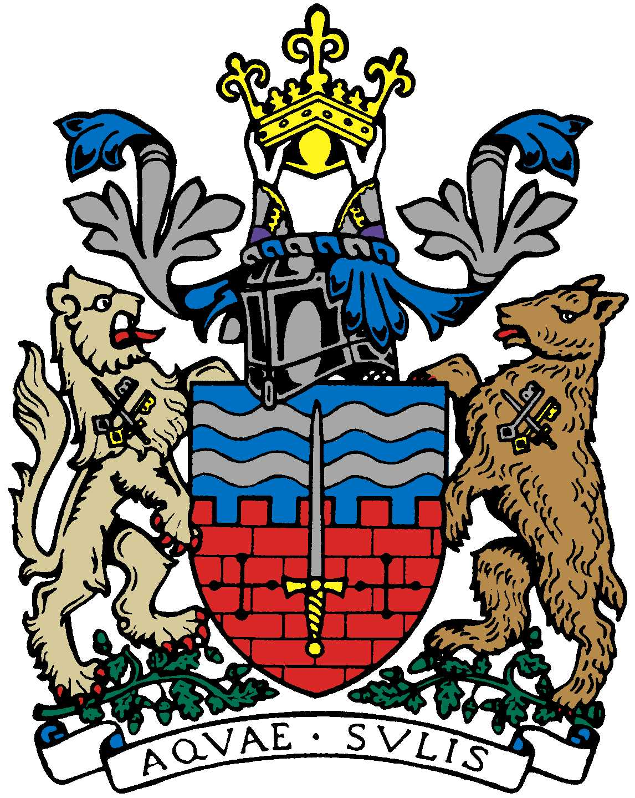

BATH AND BEPPU FRIENDSHIP ASSOCIATION

AGENDA
23rd March 2021, 6pm
General Zoom Meeting, open to all BBFA members

 | Item | By
1 | Welcome | Paul
2 | Minutes of Last Meeting | Jane
3 | Charter Trustees grant application | Paul
4 | Website hosting and domain renewal payments | Jane
5 | Emakimono scrolls update | Jane/Kaoru
6 | Sake event, Sat. 5th June 2021 | Paul/Ed
7 | Olympic-themed schools’ activities? | Ed
8 | Other news/updates from committee members | All
9 | Any volunteers to help with website (emakimono)/social media? | All
10 | AOB | All
11 | Date/Details of Next Meeting

