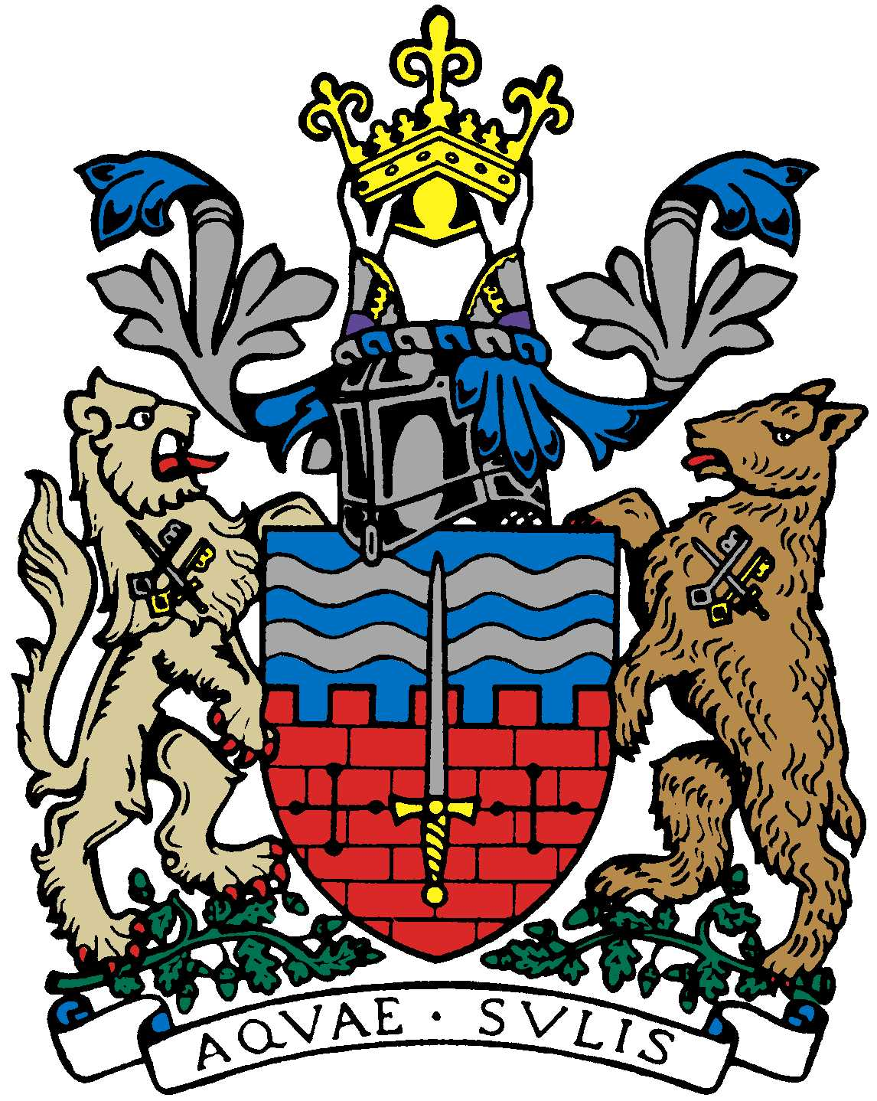

BATH AND BEPPU FRIENDSHIP ASSOCIATION

AGENDA
18:00 20th November 2019
Comins Tea House, Monmouth St., Bath

 | Item | By
1 | Welcome | Paul
2 | Minutes of Last Meeting | Jane
3 | Feedback from BBFA members’ Rugby World Cup experiences
4 | 3 Nations Rugby Tour in 2020/2021 | Paul
5 | RWC legacy project 1: Beppu Day -KJ | Kaoru
6 | RWC legacy project 2:Summer school in Bath | Kaoru
7 | Bath Beppu Arts Project | Paul Bradley-Cong
8 | Update on Japanese Festival at Ashton Court Manor on 3/11 | Yumiko
9 | Emakimono leaflet including Michiyo’s visit to Beppu school | Matthew, Michiyo
10 | Update on possible Bath schools’ Japanese Olympic themed event | Ed Harker
11 | Update on Judo themed event at MEAA with Bath Uni. Plus, Involvement in celebration of Japanese art and culture via large Sports festival in Trowbridge in July 2020 | Yukie
12 | Update on twinning road sign proposal and getting certificate at Mayor’s Parlour re-done | Paul
13 | Planning of New Year’s Dinner on 17/1: volunteer organisers required | All
14 | AOB
15 | Next Meeting

