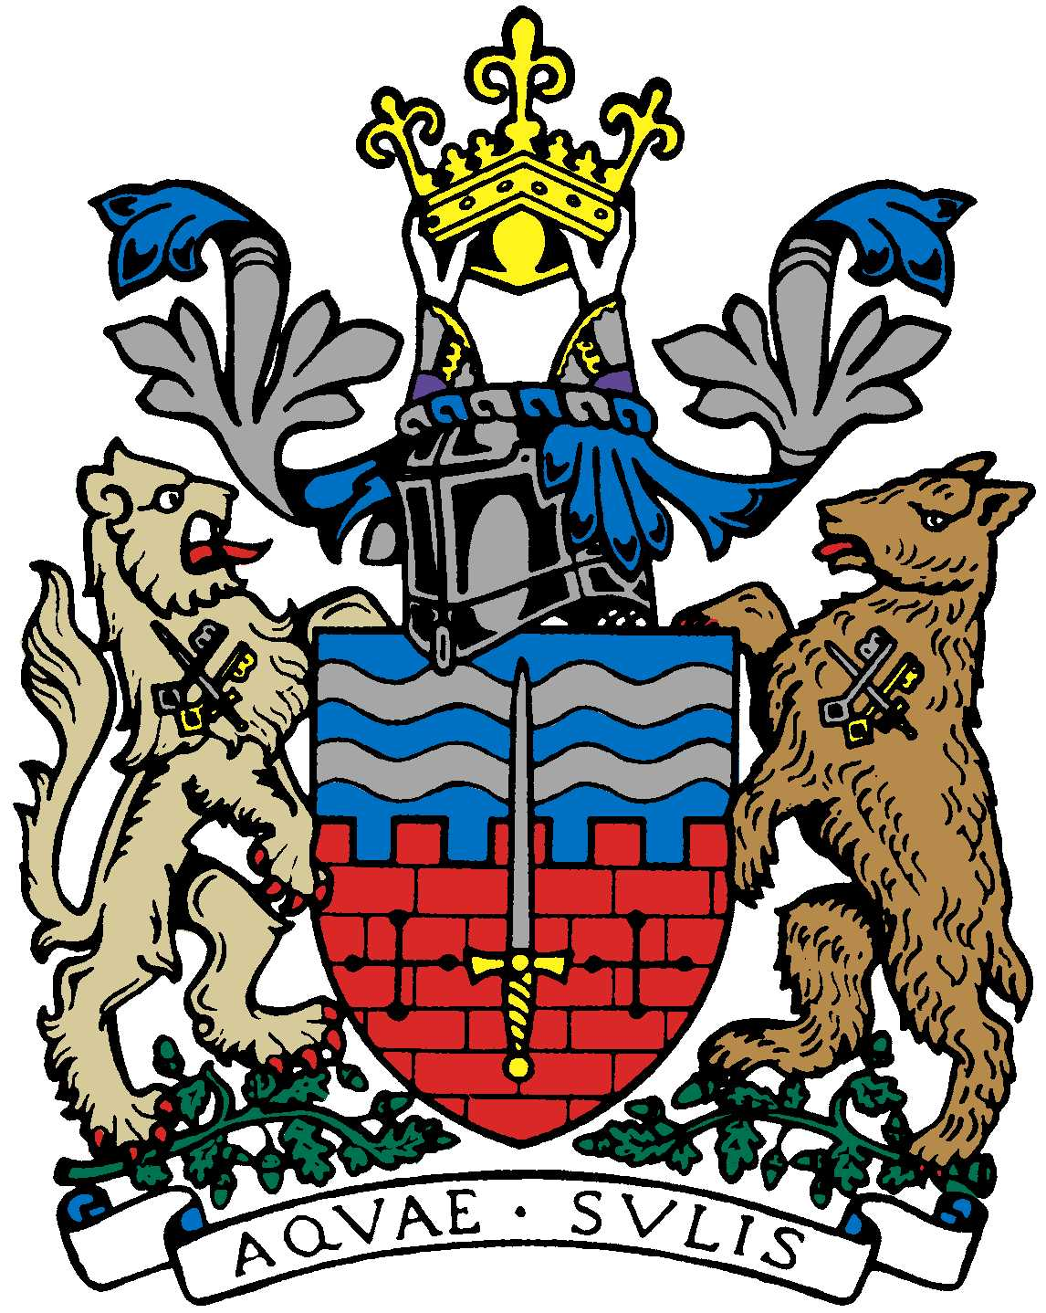

BATH AND BEPPU FRIENDSHIP ASSOCIATION

AGENDA
17:30 5th February 2020
Cabinet Room, Guildhall, Bath

 | Item | By
1 | Welcome | Paul
2 | Minutes of Last Meeting | Jane
3 | Update on New Year dinner on 17/1 | Kaoru
4 | Sake event on 5/6 | Kaoru
5 | 3 Nations Rugby Tour in 2020/2021 | Paul
6 | RWC legacy project 1: Beppu Day -KJ | Kaoru
7 | RWC legacy project 2:Summer school in Bath | Kaoru
8 | Bath Beppu Arts Project | Paul Bradley-Cong
9 | Emakimono update | Michiyo, Jane
10 | Bath schools’ Japanese Olympic themed event | Ed Harker
11 | Update on Judo themed event at MEAA with Bath Uni. Plus, Involvement in celebration of Japanese art and culture via large Sports festival in Trowbridge in July 2020 | Yukie
12 | Update on twinning road sign proposal and getting plaque at Mayor’s Parlour re-done | Paul
13 | AOB
14 | Next Meeting

