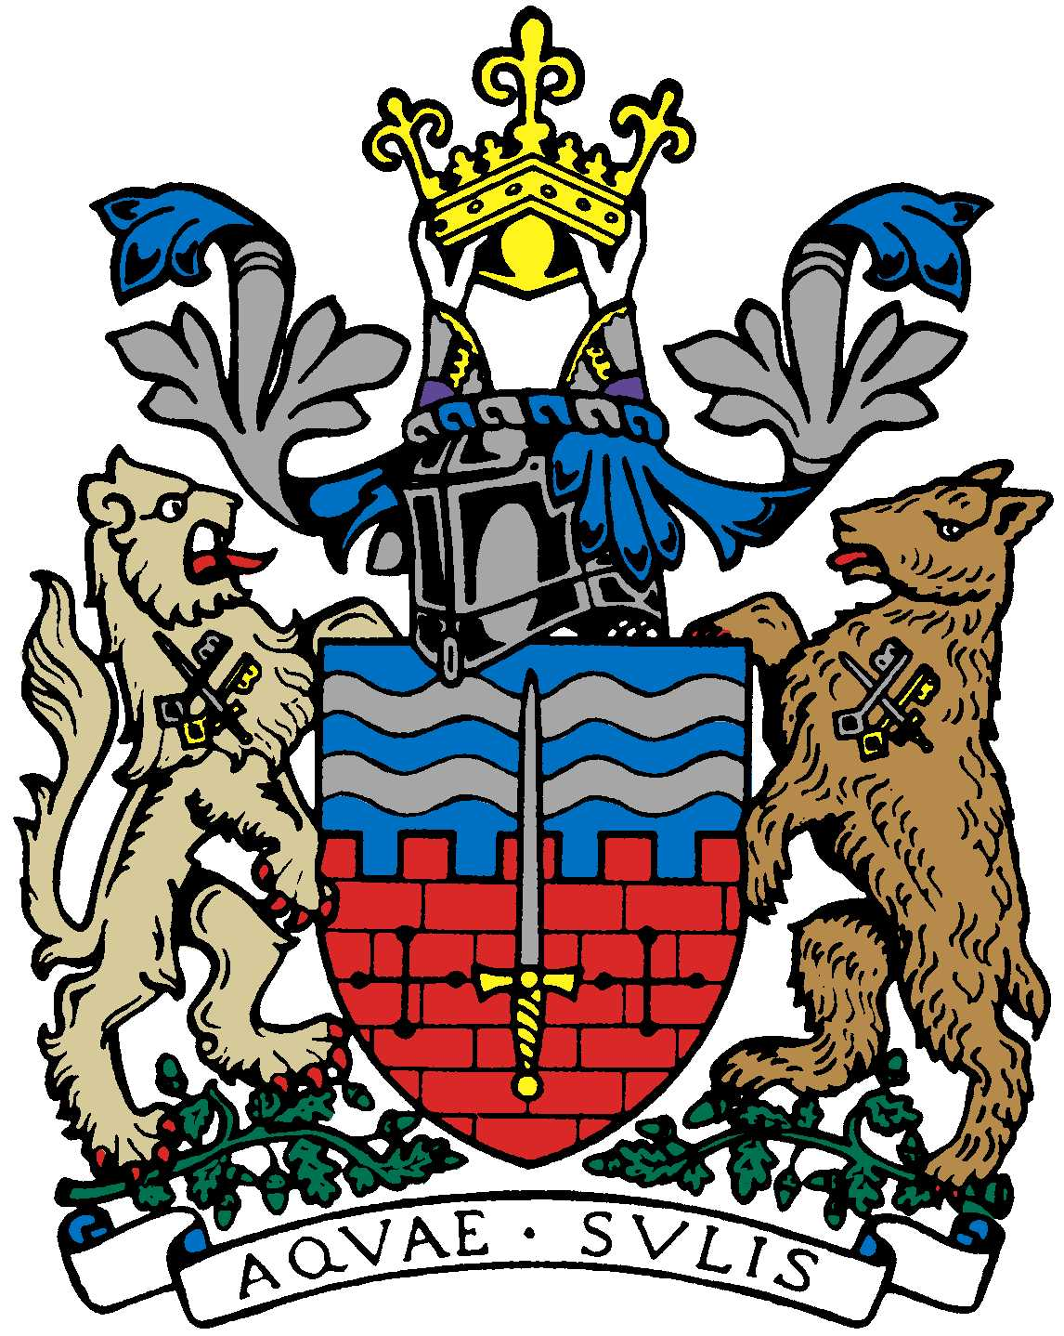

BATH AND BEPPU FRIENDSHIP ASSOCIATION

AGENDA
18:00 19th September 2019
Comins Tea House, Monmouth St., Bath

 | Item | By
1 | Welcome | Paul
2 | Minutes of Last Meeting | Jane
3 | Complimentary Rugby World Cup Tickets | Kaoru
4 | Update on Mini Japan Day at MEAA 7/7 | Yukie
5 | Emakimono leaflet | Matthew
6 | Bristol Japanese Festival at Ashton Court Manor on 3/11. | Yumiko
7 | Return rugby trip to Bath | Paul
8 | General event planning for the coming year | All
9 | Membership (associate/multiple, etc.) | All
10 | AOB
11 | Next Meeting

All members are welcome to attend. Tea will be provided and there is a lovely selection of cakes and light refreshments for sale.

