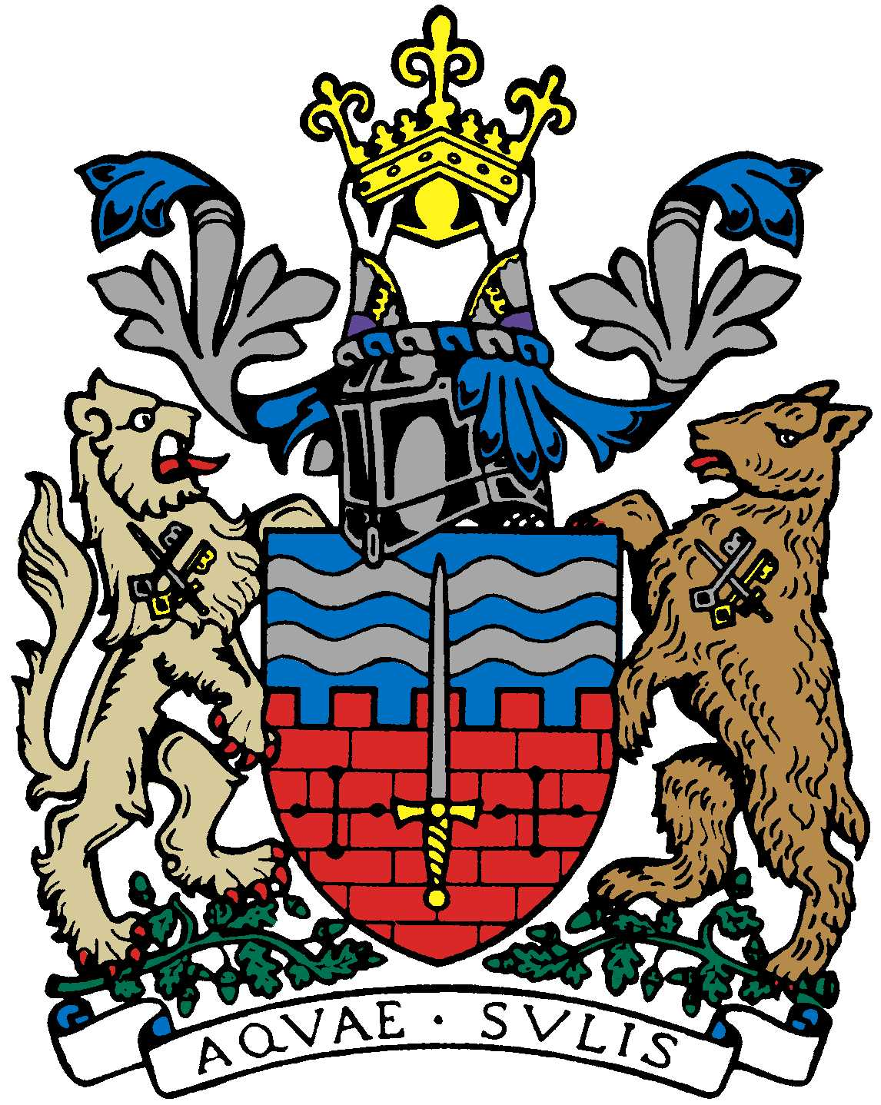

BATH AND BEPPU FRIENDSHIP ASSOCIATION

AGM AGENDA
12:00 20th June 2019
The Mayor’s Parlour, The Guildhall, Bath

 | Item | By
1 | Welcome | Paul
2 | Minutes of Last Meeting (NB: dates requested for rugby? £500 grant received last year? St. Michael’s bill obtained? DT intending to do talks or not?) | Jane
3 | Free Rugby World Cup Tickets | Kaoru
4 | Yumiko to be committee member?
5 | Update on Sake Event 24/5 | Kaoru
6 | Mini Japan Day at MEAA | Yukie
7 | Progress on Embassy visit? | Kaoru
8 | Emakimono leaflet | Matthew
9 | AOB
10 | Next Meeting

Close meeting and informal social session for those able to stay

