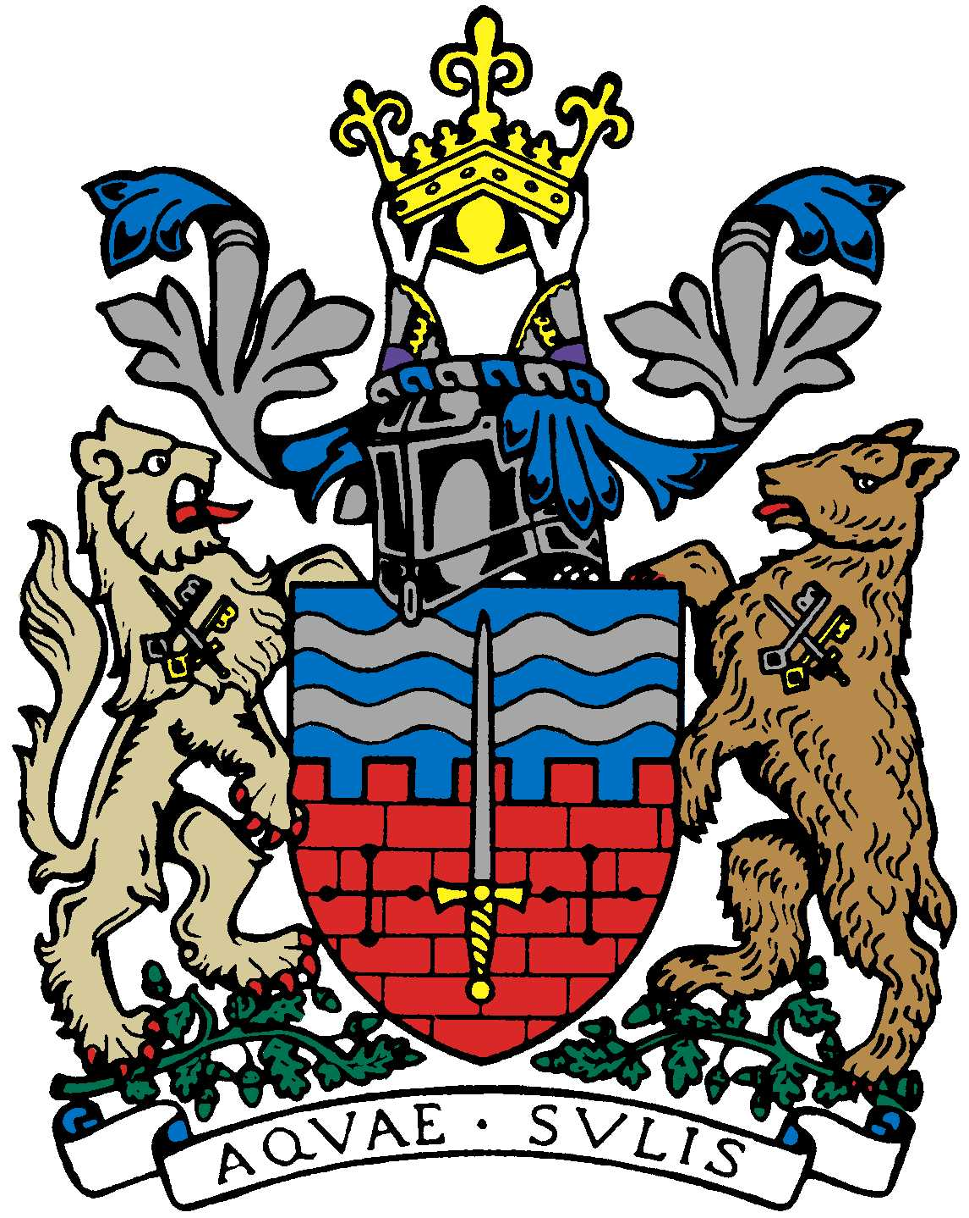

BATH AND BEPPU FRIENDSHIP ASSOCIATION

Committee Meeting AGENDA
18:00, 20th November 2018
The Mayor’s Parlour, The Guildhall, Bath

 | Item | By
1 | Welcome | Paul
2 | Minutes of Last Meeting | Jane/Paul
3 | Kunisaki/Glastonbury link: any Anglo-Japanese families known in Glastonbury area? | All
4 | Visit of Beppu Mayor 19/20/21 Dec. | Paul/Kaoru
5 | Emakimono Update | Jane/Michiyo/Mieko
6 | Shin’ai Girl’s High School visit 27-29 March 2019 | Jane/Mieko/Paul
7 | BRLSA World Affairs through our Eyes Japan - Mr Tsuruoka, Japanese Ambassador to the UK | Kaoru/All
8 | New Year Dinner 19/1 | Kaoru
9 | David Tanner Talks about Japan | David/Paul
10 | Progress on shared PDF files for BBFA | Sachiko/Yukie
11 | Rugby World Cup Free Ticket Opportunity | Kaoru
12 | Next Meeting | Jane

