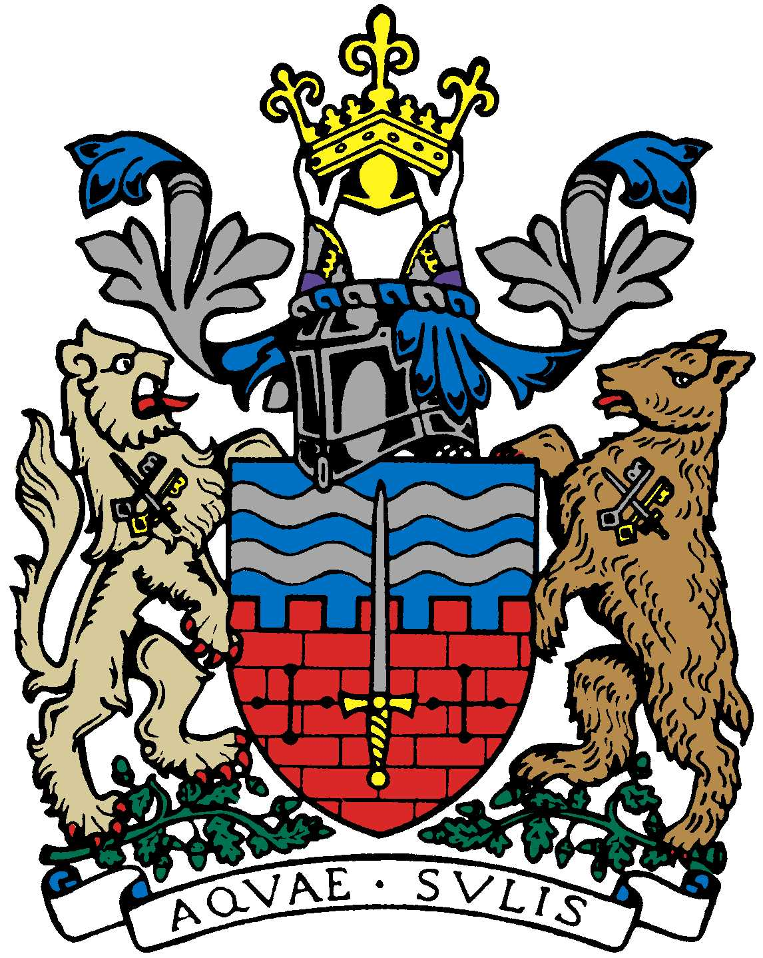

BATH AND BEPPU FRIENDSHIP ASSOCIATION

Committee Meeting AGENDA
18:00, 18th October 2018
The Mayor’s Parlour, The Guildhall, Bath

 | Item | By
1 | Welcome | Paul
2 | Minutes of Last Meeting | Jane/Paul
3 | Review sake event on 6/10 | Kaoru
4 | Review Bristol Japan Cultural Showcase event 13/10 | Yumiko-san, Yukie, Sachiko
5 | Review of Kunisaki/Glastonbury meeting with Hiroaki Kaneto | Paul
6 | Visit of Beppu Mayor 20/21 Dec. | Paul
7 | Review of Visit by Prof. Hayashi | Paul
8 | Emakimono Update | Mieko-san
9 | Shin’ai Girl’s High School visit March 2019 | Mieko-san/Paul
10 | BRLSA World Affairs through our Eyes Japan - Mr Tsuruoka, Japanese Ambassador to the UK | Kaoru
11 | Honda Update | Paul/Helen Akiyama
12 | New Year Dinner 18/1 | Kaoru
13 | Next Meeting | Jane

Close meeting. Time to socialize afterwards with soft drinks & snacks!

