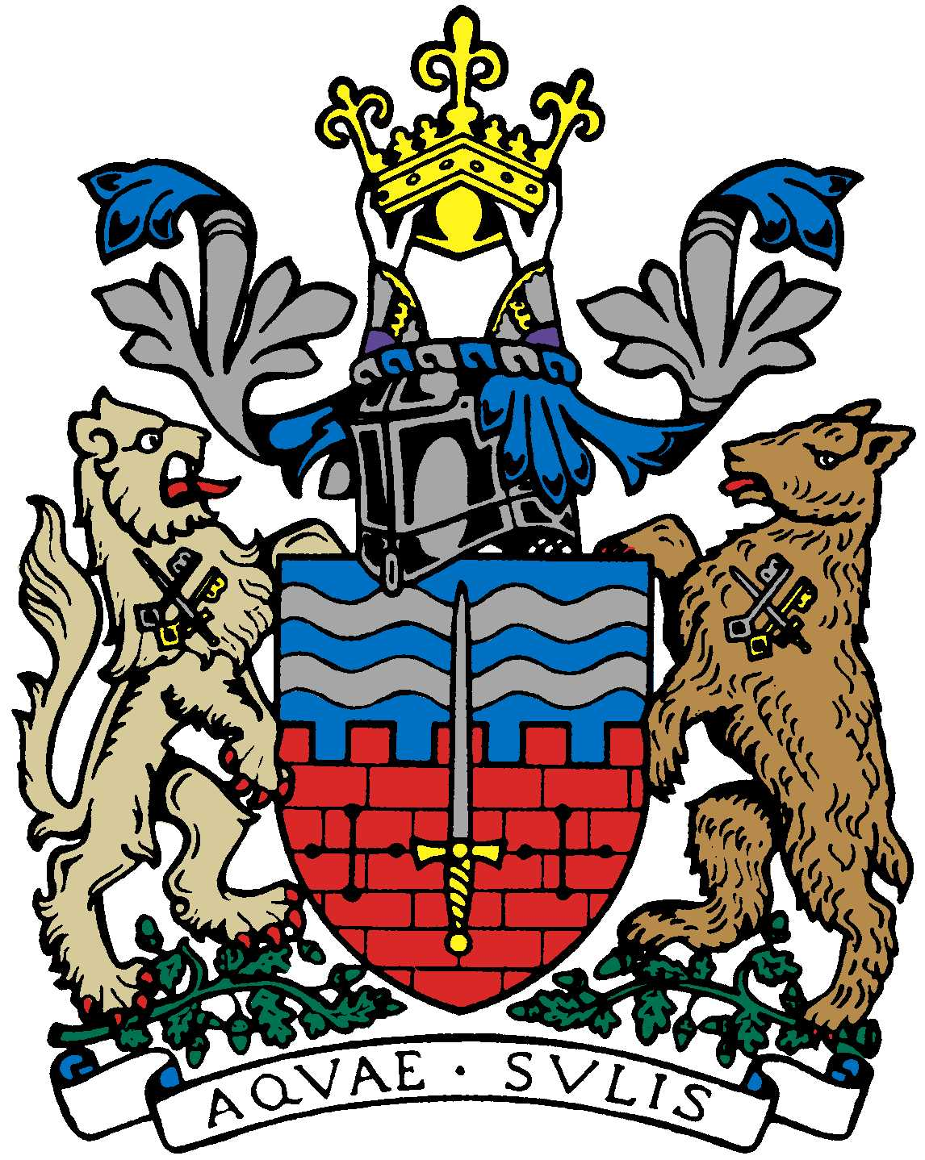

BATH AND BEPPU FRIENDSHIP ASSOCIATION

Committee Meeting AGENDA
18:00 6th September 2018
The Mayor’s Parlour, The Guildhall, Bath

 | Item | By
1 | Welcome | Paul
2 | Minutes of Last Meeting | Paul
3 | Informal sake event on 6/10 | Yukie/Caroline
4 | Women’s Adventure trip to Japan/Presentation 6/10 (TBC) | Caroline/Tania
5 | Bristol Japan Cultural Showcase event 13/10 | Yumiko-san
6 | Visit of Beppu Mayor this autumn | Paul
7 | AOB: Google Drive account for images; Emakimono; etc.
8 | Next Meeting Thursday 18 October at 6pm

Close meeting.

