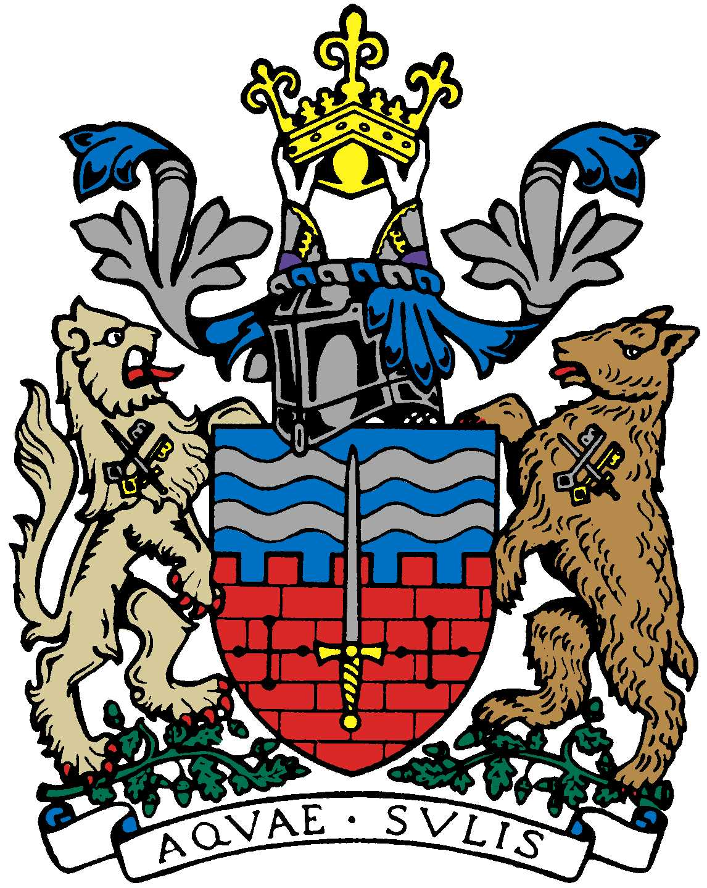

BATH AND BEPPU FRIENDSHIP ASSOCIATION

Committee Meeting AGENDA
18:30 19th July 2018
Kaposvar Room, The Guildhall, Bath

 | Item | By
1 | Welcome | Kaoru
2 | Minutes of Last Meeting | Jane
3 | Review informal sake event on 6/10 | Kaoru
4 | Review Women’s Adventure trip to Japan/Presentation 6/10 | Caroline/Tania
5 | Review Bristol Japan Cultural Showcase events: June/Oct | Yumiko-san
6 | Review Bath Uni MBA Sake event | Mr. Takeuchi
7 | Emakimono Update | Mieko-san
8 | Summer Obon Picnic? | Mieko-san
9 | Twinning Owl Update | Paul
10 | Review Tea Ceremony workshop event at MEAA | Yukie
11 | Update on Japan-themed talks by DT | David Tanner
12 | Website/social media update | Kaoru/Jane/Tania etc.
13 | GDPR Update
14 | Next Meeting | Jane

Close meeting. Time to socialize afterwards.

