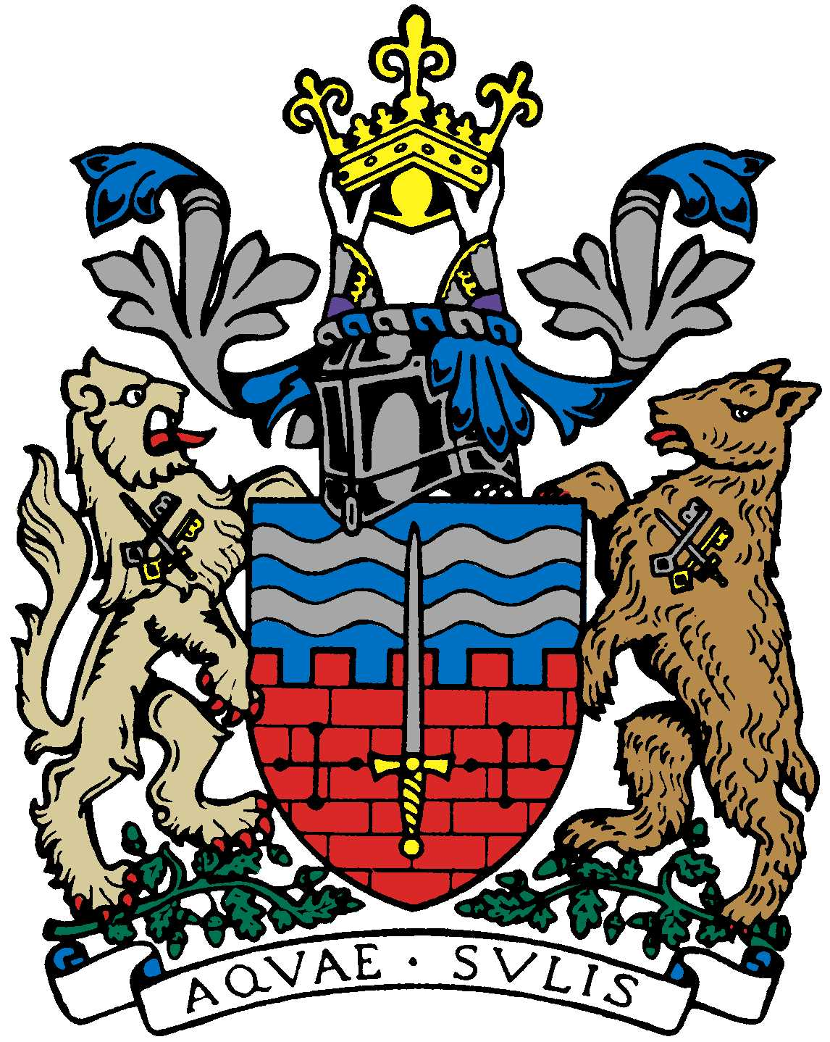

BATH AND BEPPU FRIENDSHIP ASSOCIATION

Committee Meeting AGENDA
18:00 21st May 2018
The Mayor’s Parlour, The Guildhall, Bath

 | Item | By
1 | Welcome | Paul
2 | Minutes of Last Meeting | Jane
3 | Tony McNicol’s role (website etc) | Jane
4 | Review Women’s Adventure Expo Event | Caroline?
5 | Review Tsutefude Event | Attendees
6 | Data protection laws/membership form | Paul/Caroline
7 | Japan Festival/Sake Event October | Paul
8 | Summer Obon Picnic?
9 | Japanese Film Society progress | Paul
10 | Sake event organized by Bath Uni MBA 30/6
11 | Emakimono | Michiyo
12 | AOB
13 | Next Meeting & schedule mtgs for rest of year | Jane

Close meeting

