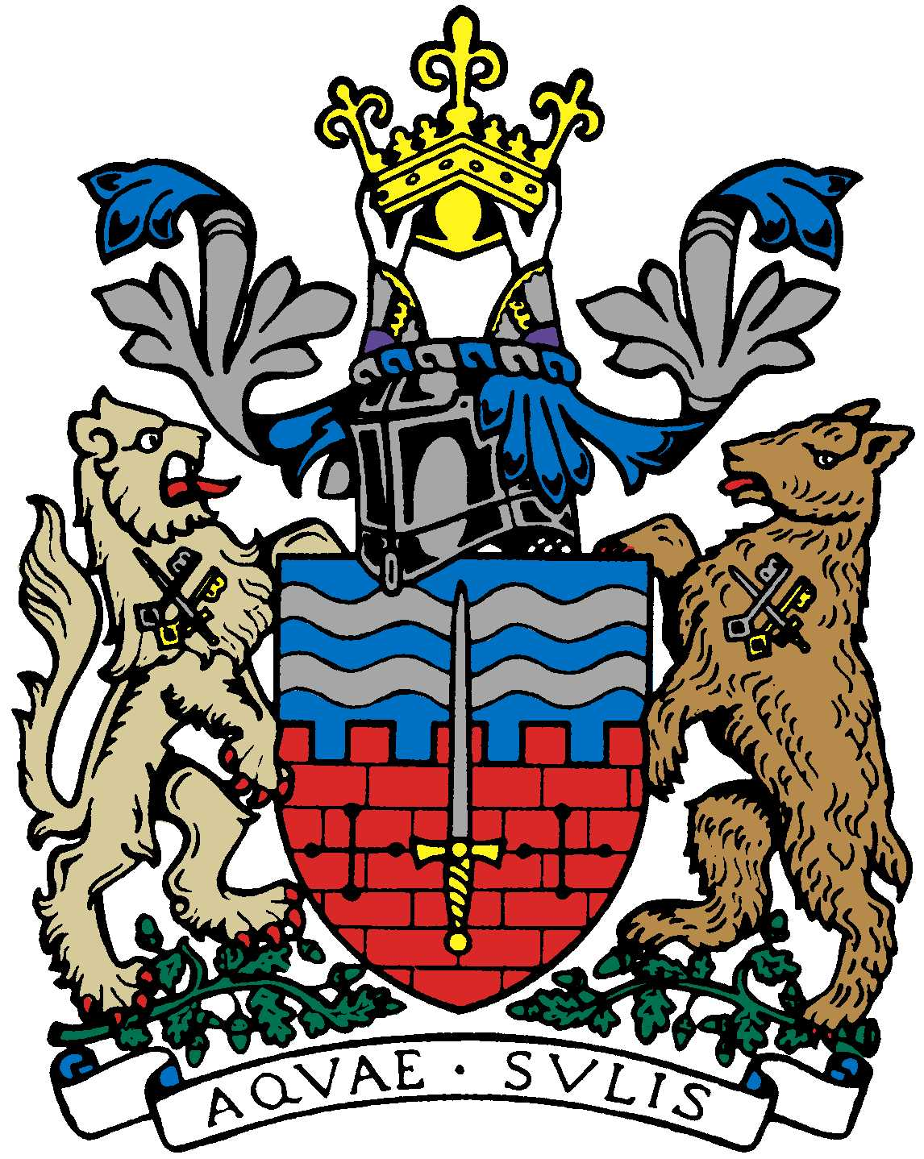

BATH AND BEPPU FRIENDSHIP ASSOCIATION

AGM AGENDA
18:00 26th April 2018
The Mayor’s Parlour, The Guildhall, Bath

 | Item | By
1 | Welcome | Paul
2 | Minutes of Last Meeting | Jane
3 | Chairman’s Report/ Review of 2017/2018 | Paul
4 | Secretary’s Report | Jane/Caroline
5 | Accounting Report | Alfred/Yukie
6 | Elections for next year’s Committee | Paul
7 | Japan Festival/Sake Event October | Paul
8 | Cherry Blossom viewing event | Tony/Mieko
9 | Women’s Adventure Expo Event involving BBFA | Tania
10 | Tsutefude | Helen Akiyama
11 | Japanese Film Society progress | Paul
12 | Sake event organized by Bath Uni MBA | Mr Takeuchi
13 | AOB
14 | Next Meeting

Close meeting and informal social session

