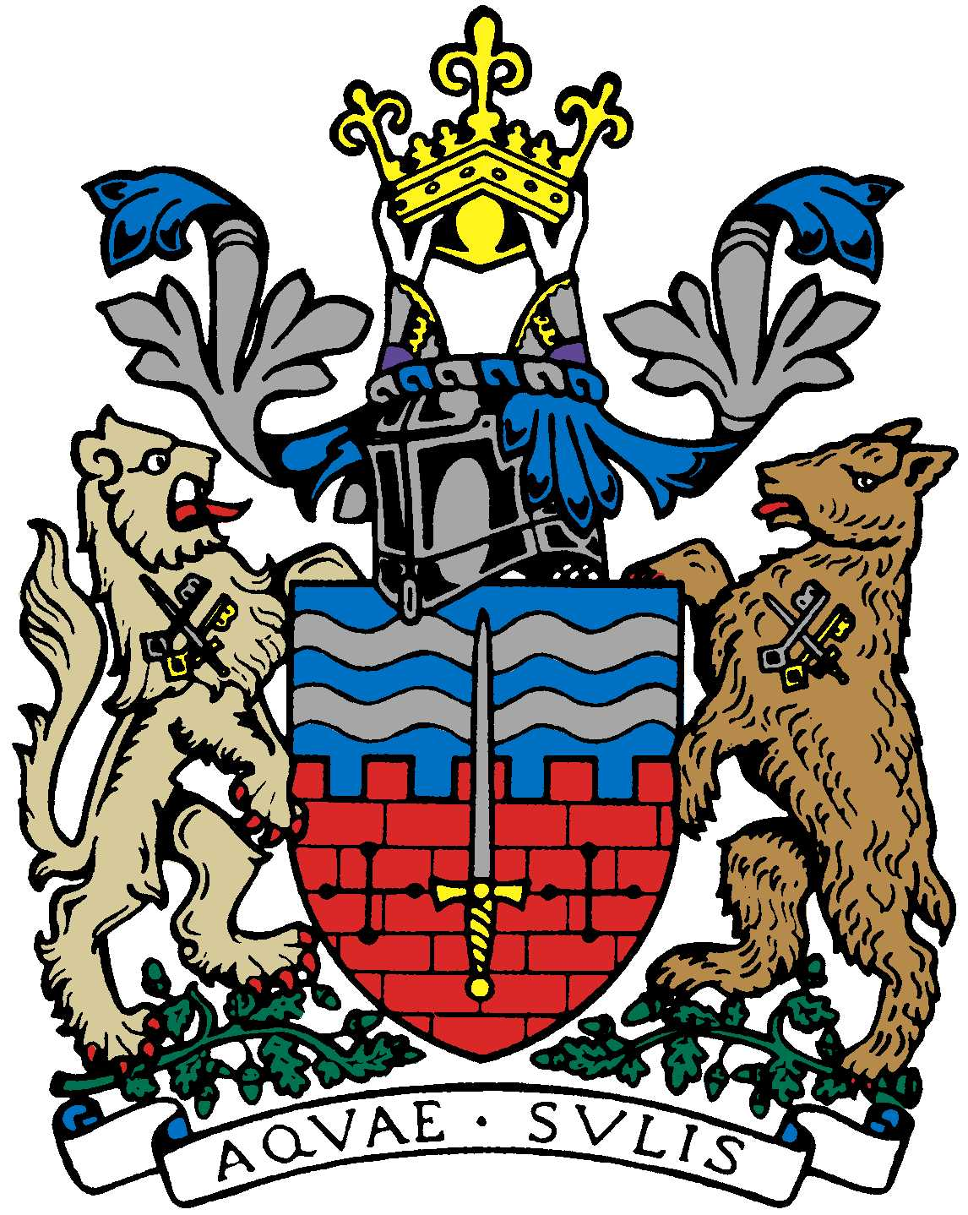

BATH AND BEPPU FRIENDSHIP ASSOCIATION

AGENDA
18:00, 14th March 2018
The Council Chamber, The Guildhall, Bath

 | Item | By
1 | Welcome | Paul
2 | Minutes of Last Meeting | Jane
3 | Twinning Forum  The next 4 are 28 Feb, 16 May, 22 Aug and 7 Nov. PC cannot attend the 28 Feb or 22 Aug. PC will prepare a draft report for the 28 Feb to circulate to the Committee. He needs a volunteer from the committee to represent BBFA at the Twinning Forum in Feb and Aug. | Paul
4 | Japan Festival/Sake Event: how to proceed in 2018
5 | Possible 2018 Cherry Blossom Viewing Event?
6 | Rugby Youth Tour to Beppu, February 2018 | Paul & Kaoru
7 | Women’s Adventure Expo Event involving BBFA (new date? April 28th) | Caroline & Tania
8 | Tsutefude – mid May | Helen Akiyama/Yukie
9 | I.T. Update (Masato Blog, I.T. sub-committee, website etc.) | Tony/Jane/  Mieko
10 | Members’ Social Dinner 27.1.18 | Kaoru
 | Plan for Alfred’s successor as Treasurer
11 | AOB (Financial Matters (Emakimono, Beppu Bar, etc.)
12 | Next Meeting

