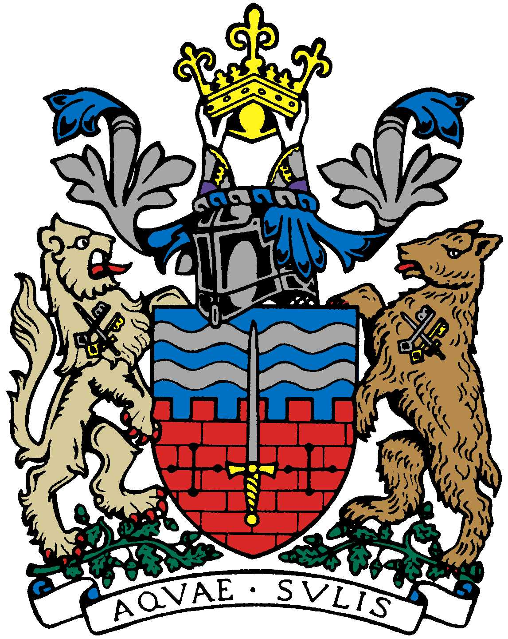

BATH AND BEPPU FRIENDSHIP ASSOCIATION

AGENDA
18:00 22nd January 2018
The Mayor’s Parlour, The Guildhall, Bath

 | Item | By
1 | Welcome | Paul
2 | Minutes of Last Meeting | Jane
3 | Review of 2017 | Paul
4 | Reporting back on recent Beppu visit | Paul & Yukie
5 | Rugby Youth Tour to Beppu, February 2018 | Paul & Kaoru
6 | Women’s Adventure Expo Event involving BBFA (new date? April 28th) | Caroline & Tania
7 | Japan Festival
8 | Tsutefude – mid May | Helen Akiyama/Yukie
9 | I.T. Update (Masato Blog, I.T. sub-committee, website etc.) | Tony/Jane/  Mieko
10 | Members’ Social Dinner 27.1.18 | Kaoru
11 | AOB (Financial Matters (HMRC), Emakimono, Beppu Bar, etc.)
12 | Next Meeting

