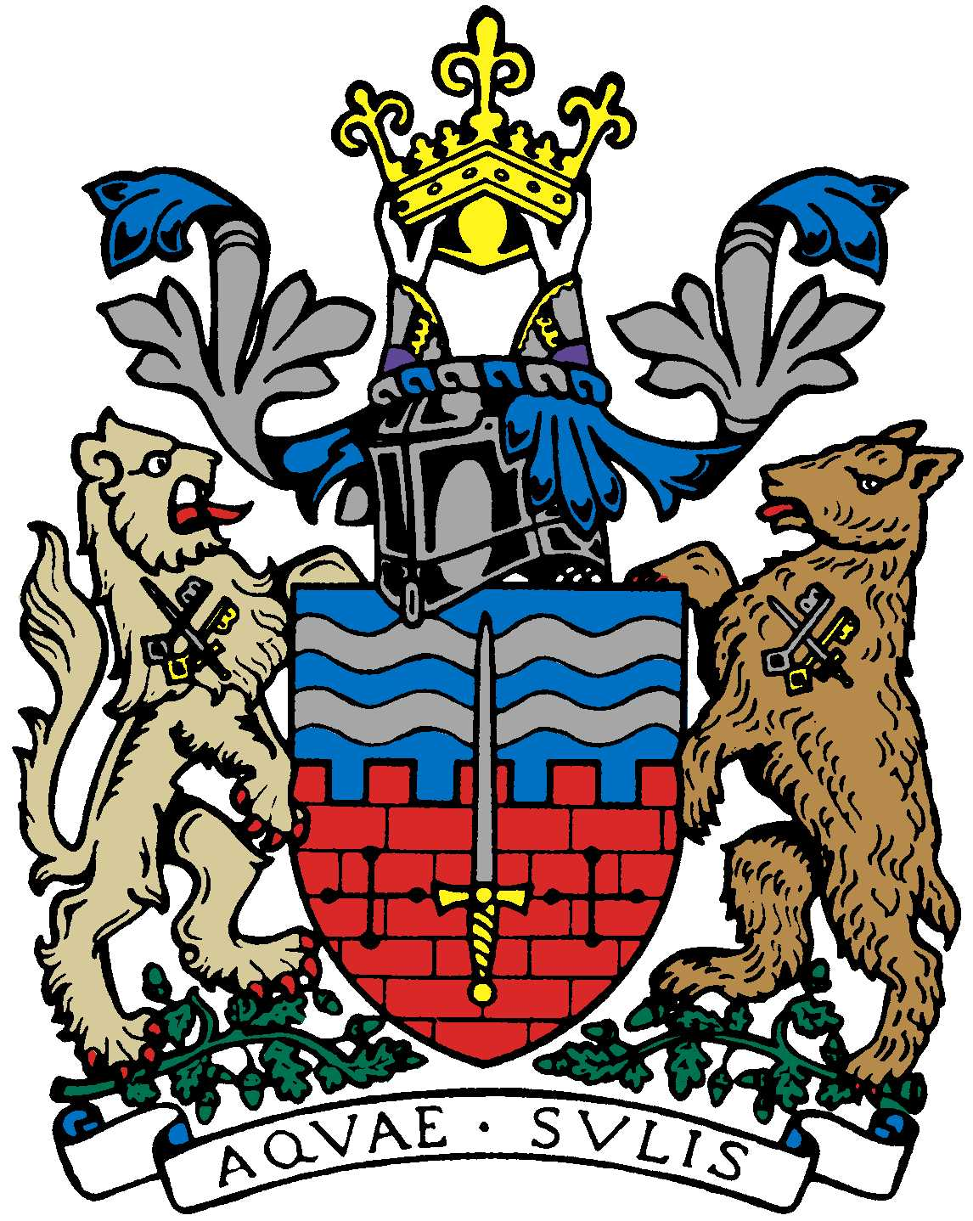

BATH AND BEPPU FRIENDSHIP ASSOCIATION

AGENDA
18:00 16th November 2017
The Mayor’s Parlour, The Guildhall, Bath

 | Item | By
1 | Welcome | Paul
2 | Minutes of Last Meeting | Jane
3 | Website Update (Masato Blog, I.T. sub-committee, etc.) | Tony/Jane/Masato/  Mieko
4 | Financial Matters (corporation tax issue) | Alfred/Paul
5 | Rugby Youth Tour to Beppu, February 2018 | Paul
6 | Women’s Adventure Expo Event involving BBFA | Caroline
7 | School Cultural Postcard Exchange | Mieko
8 | Members’ Social Dinner in Jan | Kaoru/Jane
9 | AOB (Emakimono, Beppu Bar, Paul’s Onsen Conference, etc.)
10 | Next Meeting

